Ponce de Leon Inlet Lighthouse- Brief History
During the 1800s, there was an increasingly large amount of shipwrecks occurring on Florida’s coast, partially due to the fact that there was one hundred miles of dark coast between the St. Augustine Lighthouse, and the Cape Canaveral Lighthouse. The United States Lighthouse Board decided that there should be a light station built about halfway between these two, which is Ponce de Leon Inlet. At the time it was known as the Mosquito Inlet because of its hot and humid conditions; a paradise for mosquitos. The Ponce de Leon Inlet Lighthouse was built in 1877, which makes it the last of the “brick monsters” that were built in the United States. The lighthouse stands 175-feet tall, and required over 2 million bricks be ordered for construction; not all of the bricks were used due to the rigorous travel by railway and boat the bricks endured, causing many to break (Light Station Tour Guide).
For over one hundred years, the kerosene illuminated lighthouse would be manned by the classic blue uniformed lighthouse keepers. One very neat feature of this specific light station was the fact that the keepers’ families were able to live on site, which was very rare for these brick monsters. In 1933, the Lighthouse Service was able to change out the old ways of using kerosene, and establish an electric light system, along with the Fresnel, rotating lens. This would make for a much more efficient system for the keeper, as well as the mariners at sea. Relatively soon after, thirty-seven years to be exact, the Coast Guard abandoned the lighthouse. From 1972 to 1982, the lighthouse was out of commission until the Coast Guard reactivated it. Now, the lighthouse is a tourist attraction for the town of Ponce Inlet, standing as an extremely fascinating museum for people to learn the history of the area (A Self-Guided Tour and Membership Application).
Some of the attractions within the site include:
- Main entrance building and gift shop
- Woodshed video theater and privy exhibit
- Cuban raft exhibit
- Second assistant keeper’s dwelling
- Principal keeper’s dwelling
- Lighthouse tower
- Pump house
- First assistant keeper’s dwelling
- Generator building
- Lens exhibit building
- U.S lighthouse service bell
- Oil storage building
- Garden area
- Coastal hammock

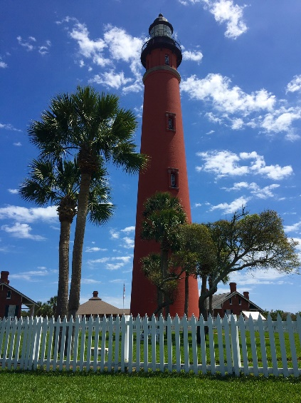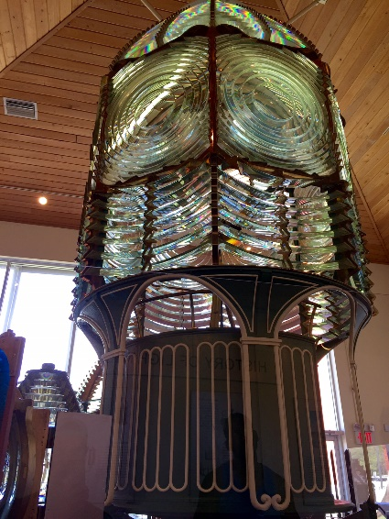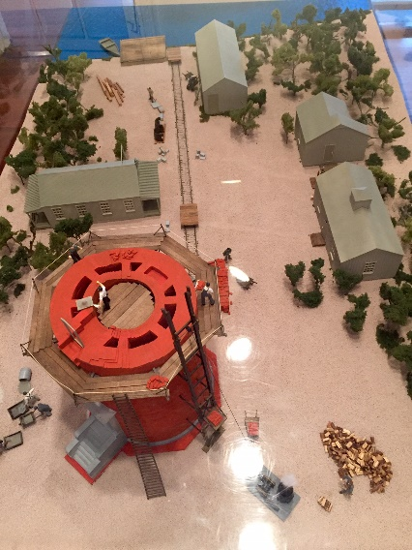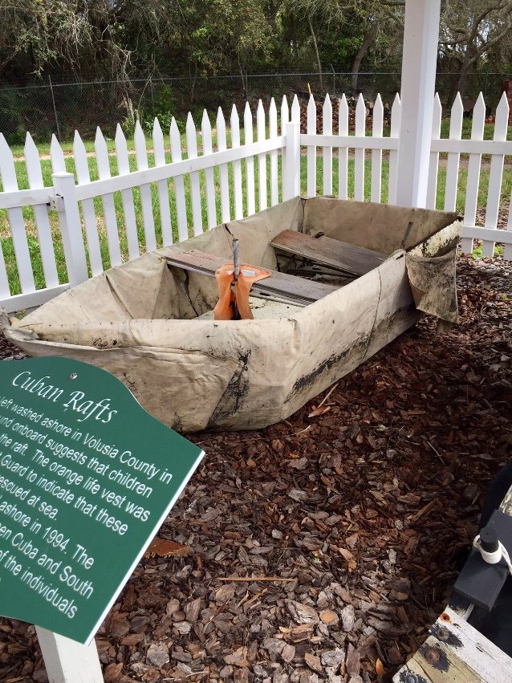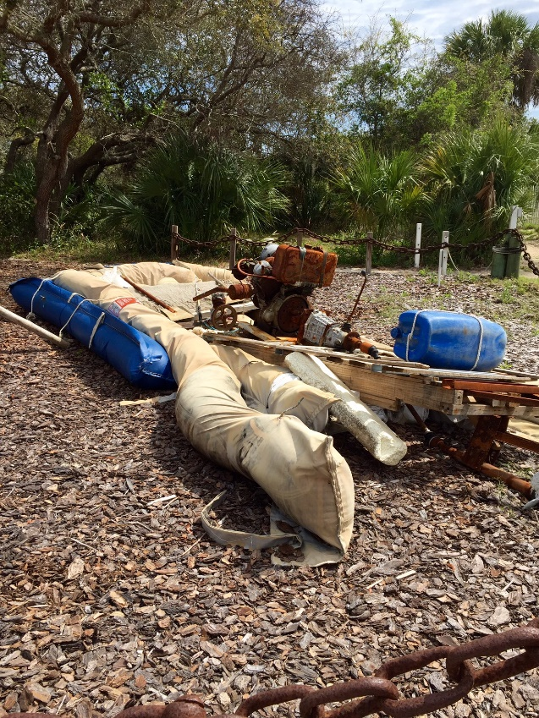
[Ponce Inlet Light Station]

References
Ponce de Leon Inlet Light Station Museum: A Self-Guided Tour and Membership Application
Ponce de Leon Inlet Light Station Museum: Tour Guide

