Plant/Animal Identification
Marine Science Center
- Blue Crab (Callinectes sapidus)
  - Habitat
    - Brackish (somewhat salty, less salty than ocean) lagoons
    - Estuaries
  - Adaptive Characteristics
    - Large range of diet
      - Mussels, snails, fish, plants, smaller blue crabs
    - High tolerance for salinity
  - Threatened/Endangered Status
    - Common
  - Threats
    - Human development
    - Pollution
  - Protection Policies
    - Reduction of pollution
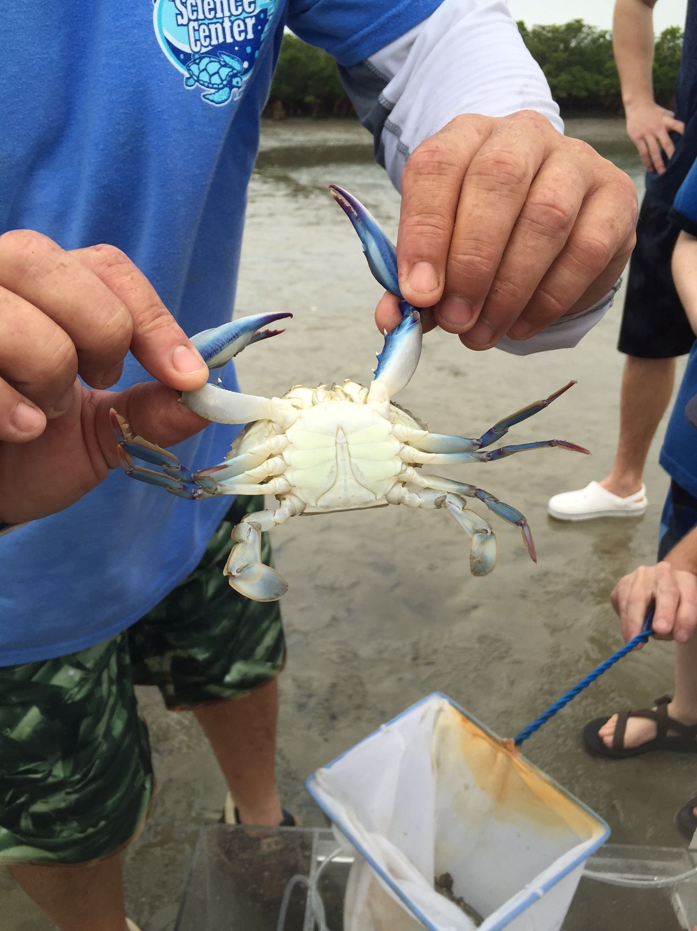
[Blue Crab: Marine Science Center]
- Mahara Fish
  - Habitat
    - Brackish lagoons
    - Estuaries
  - Adaptive Characteristics
    - Has a sandy top and a shiny, silver bottom to avoid predators
  - Threatened/Endangered Status
    - Common
  - Threats
    - Pollution
  - Protection Policies
    - N/A
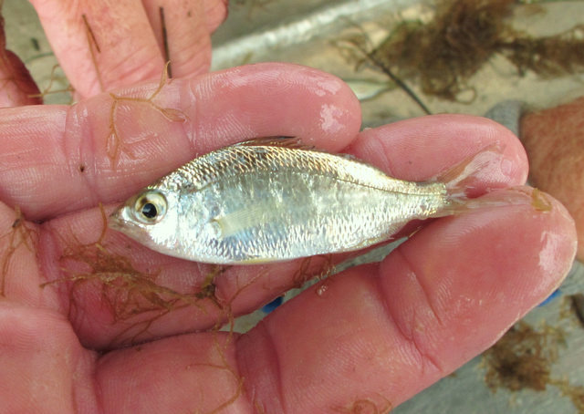
[Mahara fish: photos.al.com]

- Fiddler Crab (Uca)
  - Habitat
    - Brackish lagoons
    - Muddy burrows
    - Ocean beaches
  - Adaptive Characteristics
    - Males have a large, white pincher to wave to females
    - Change color—darker during day, pale at night
  - Threatened/Endangered Status
    - Common
  - Threats
    - Water Pollution
  - Protection Policies
    - Habitat restoration
    - Water pollution reduction
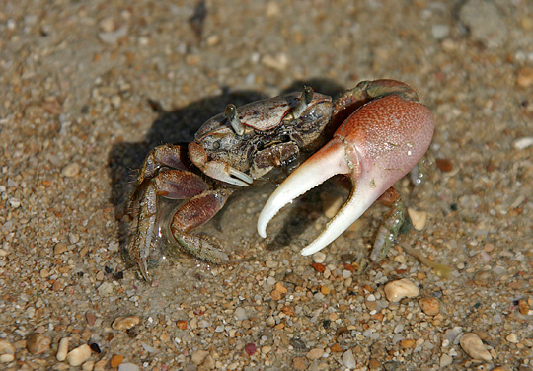
[Fiddler Crab: www.allthesea.com]

Marine Discovery Center
- Lightning Whelk (Busycon perversum)
  - Habitat
    - Fine, muddy, sandy areas
    - Low/subtidal areas
  - Adaptive Characteristics
    - Does not need to feed often—once a month (carnivorous)
    - Ability to move into bigger shell
  - Threatened/Endangered Status
    - Common
  - Threats
    - Sea birds
    - Water pollution
  - Protection Policies
    - Reduction of water pollution
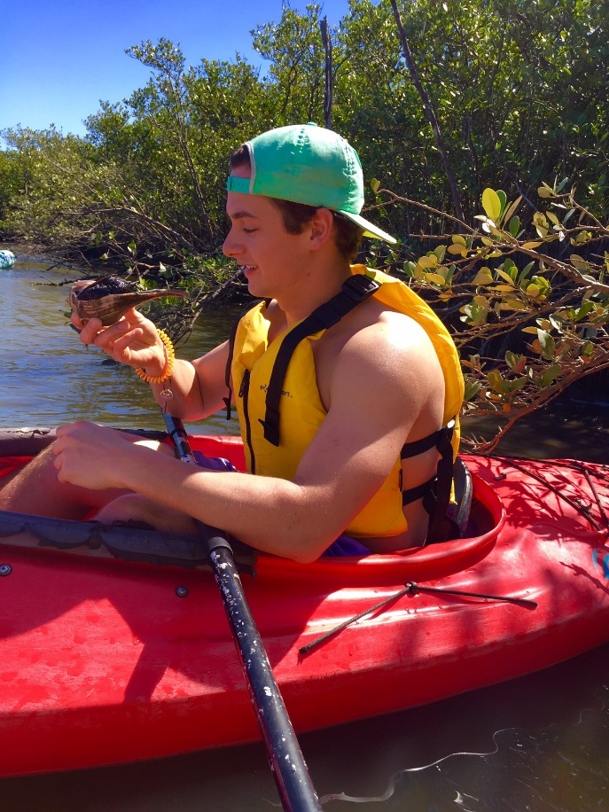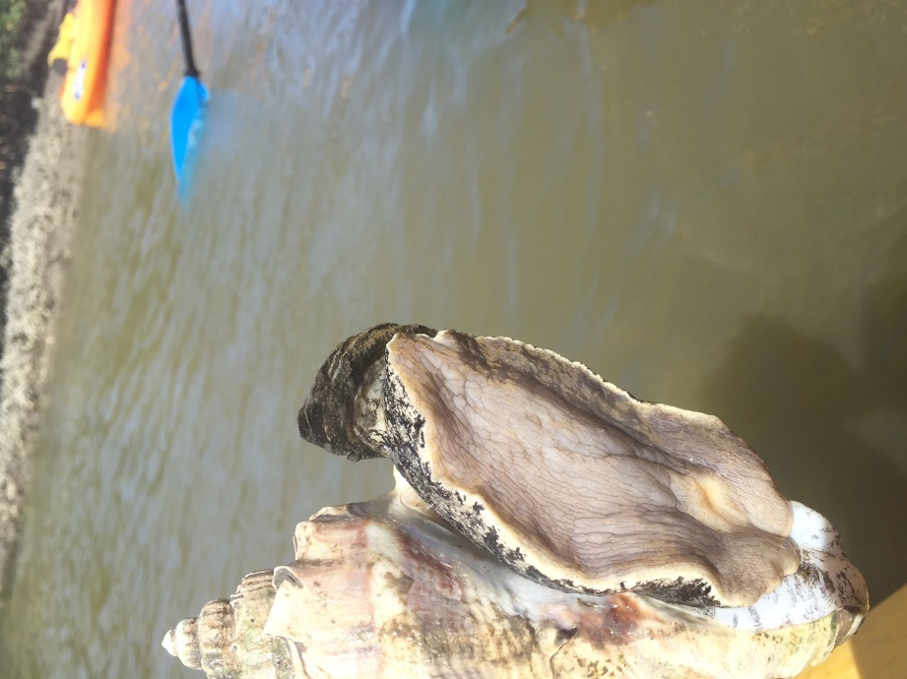
[Lightning Whelk: Marine Science Center]

- Red Mangrove (Rhizophoraceae)
  - Habitat
    - Brackish Lagoons
    - Estuaries
  - Adaptive Characteristics
    - Root structure (were known as the “walking trees”)
    - Shiny, thick, yellow sacrificial leaf that filters salt out of water
  - Threatened/Endangered Status
    - Severe danger
  - Threats
    - Human development/construction
    - Frost
    - Hurricanes
    - Climate change
  - Protection Policies
    - Local and State Government laws
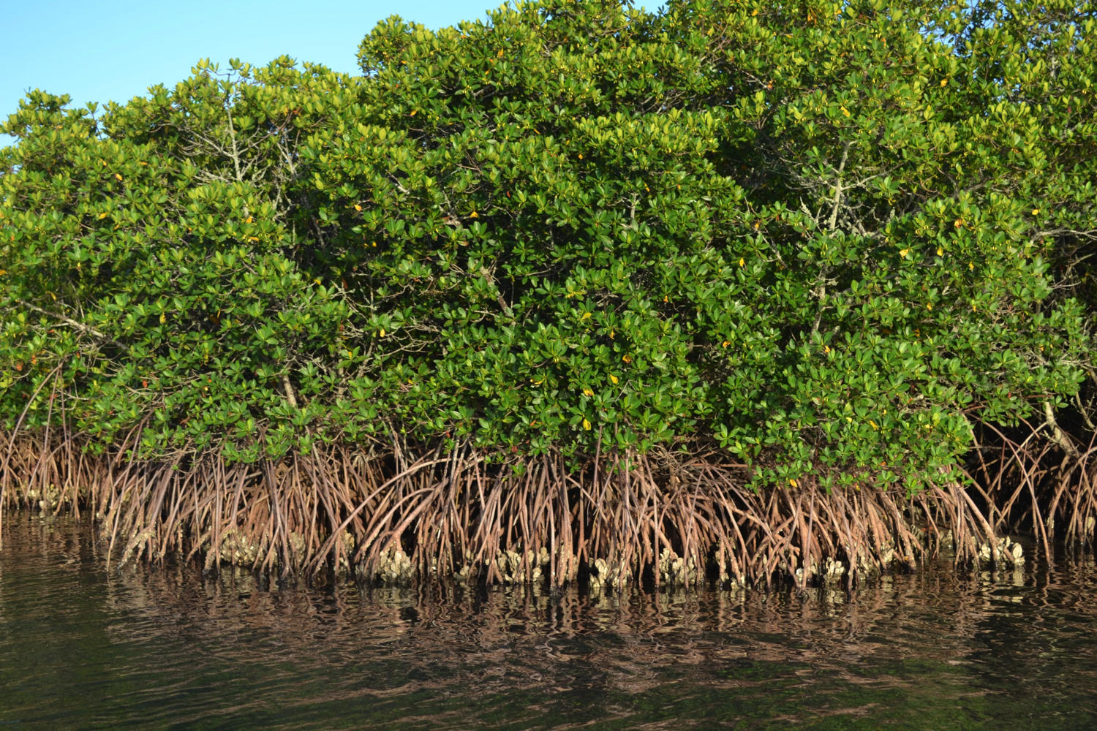
[Red mangrove: www.reelfl.org]

- Little Blue Heron (Egretta caerulea)
  - Habitat
    - Mangroves
    - Wetlands
  - Adaptive Characteristics
    - Nest low in shrubs or mangroves—avoid being seen by predators
  - Threatened/Endangered Status
    - High concern—declining population
  - Threats
    - Human development
  - Protection Policies
    - The Migratory Bird Treaty Act
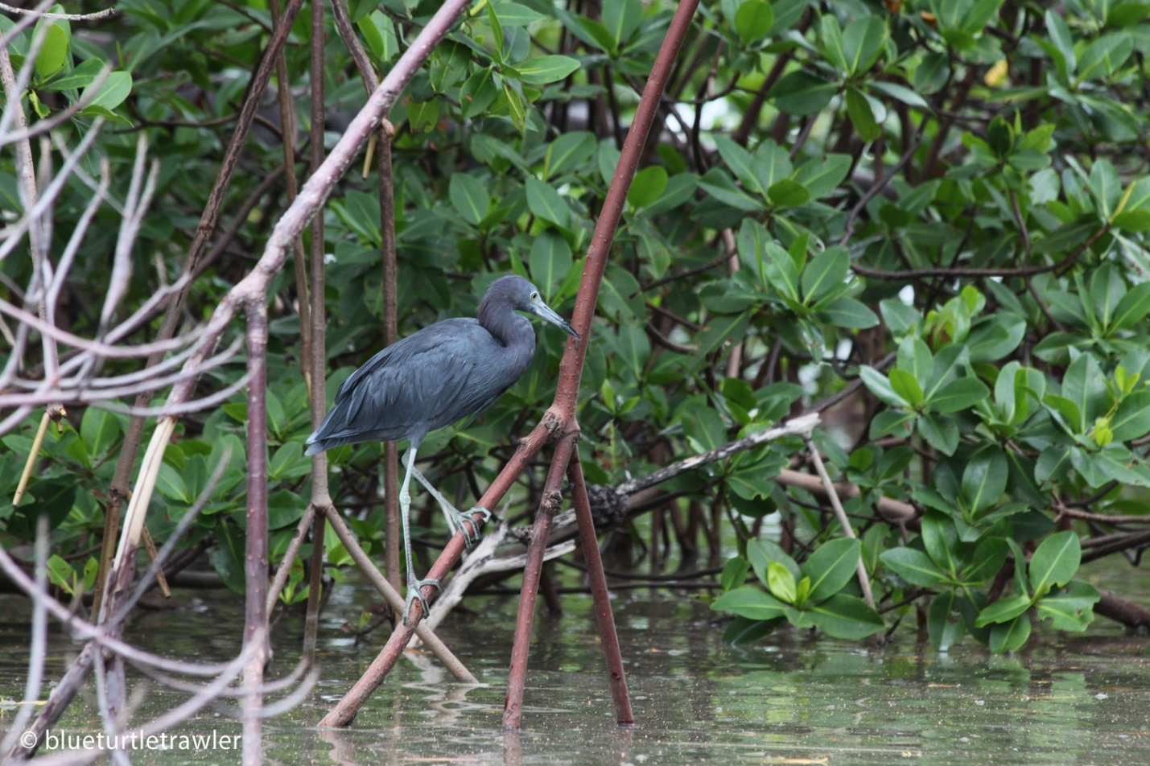
[Little Blue Heron: www.blueturtletrawler.com]

References

Blue Crabs, Blue Crab Pictures, Blue Crab Facts - National Geographic. (n.d.). Retrieved April 16, 2016, from http://animals.nationalgeographic.com/animals/invertebrates/blue-crab/
Little Blue Heron. (n.d.). Retrieved April 16, 2016, from https://www.allaboutbirds.org/guide/Little_Blue_Heron/lifehistory
Red Mangrove - National Wildlife Federation. (n.d.). Retrieved April 16, 2016, from https://www.nwf.org/Wildlife/Wildlife-Library/Plants/Red-Mangrove.aspx
Marine Science Center: Chad March, Educational Volunteer. Keith Flynn, Aquarium Manager
Marine Discovery Center: guided kayak tour

